Application Containerization

Name: Piyush Vishnoi

Roll no:R171218071

**Experiment - 13**

**Deploying Pods and Services on Minikube**

Opening Kubernetes Dashboard

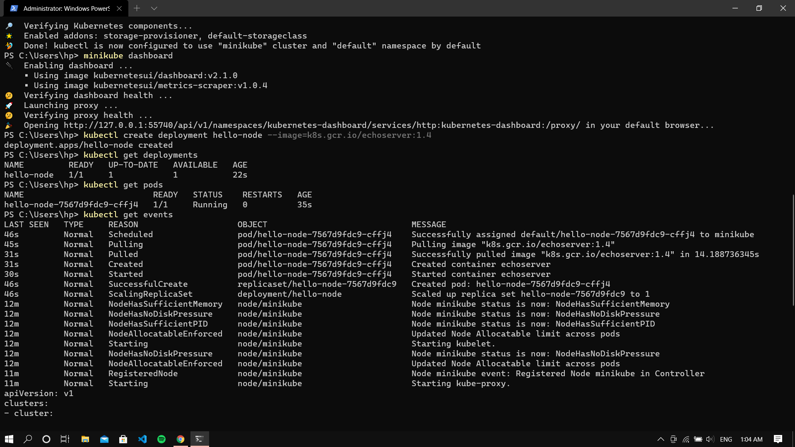

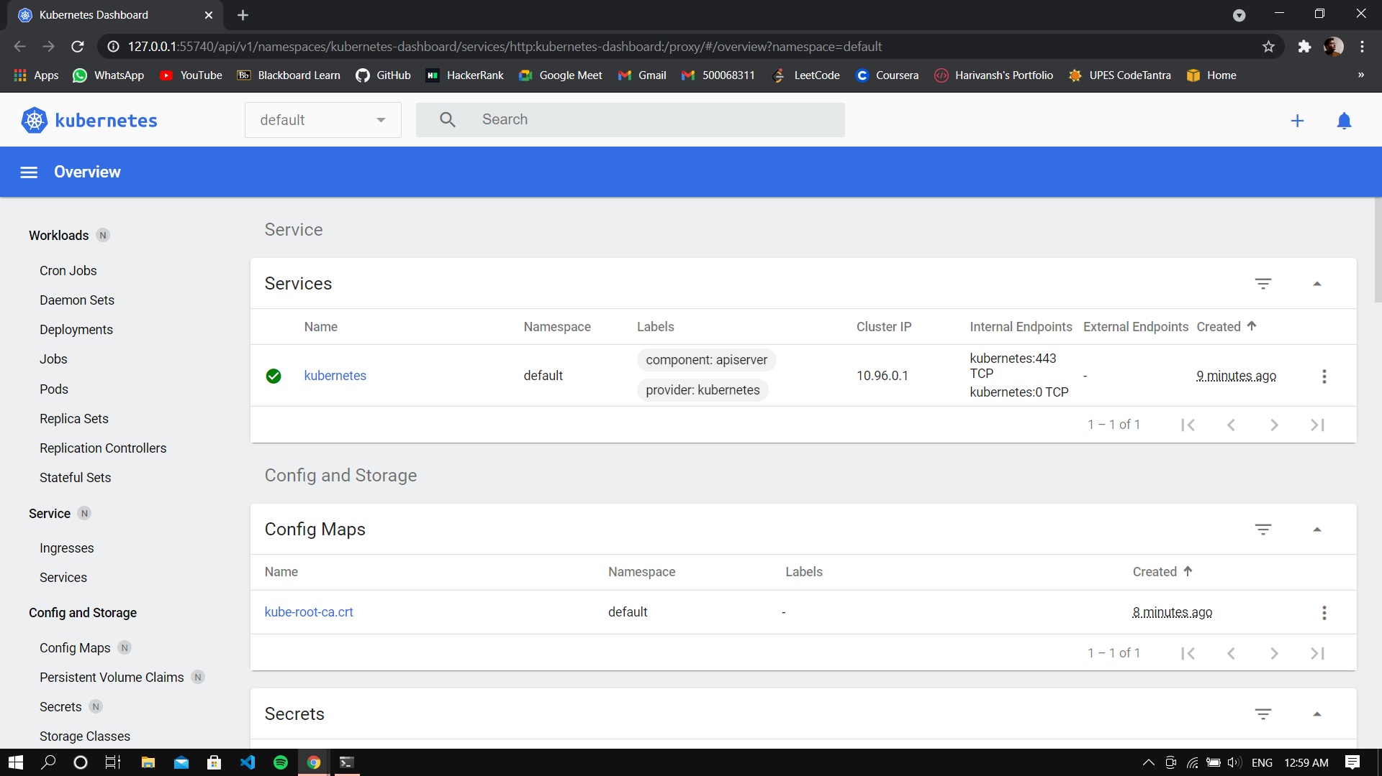

Creating a deployment, viewing the deployment and the pods



Command for viewing cluster events



Exposing the pod and creating a serivce

